 | Summer Sky Tour  Randy Culp | 

Every year, in July, our Boy Scout Troop heads off to the North Woods of Wisconsin for a week of summer camp. It's been known on (rare) occasion to rain or cloud over at night, but when it's clear, the sky is stunning. On those nights we never fail to get out our binoculars and telescopes and head down to the lakefront for stargazing.
The account here is the agenda that I loosely follow in providing a guided tour of the summer skies as visible from 45° North Latitude. This tour is designed for one topic to lead to the next, so it flows nicely and still manages to teach Astronomy under the night sky as we caravan from one constellation to another. Aside from the binoculars and telescopes I usually make a point of also bringing a highly focused flashlight which serves as an effective pointer for tracing out constellations.
Note that this tour is specifically designed to meet requirements 5, 7 and 8 (b) of the Astronomy merit badge, although of course there are lots of other tidbits here that go beyond the requirements of the badge.
Updated 14 April 2021
View to the South
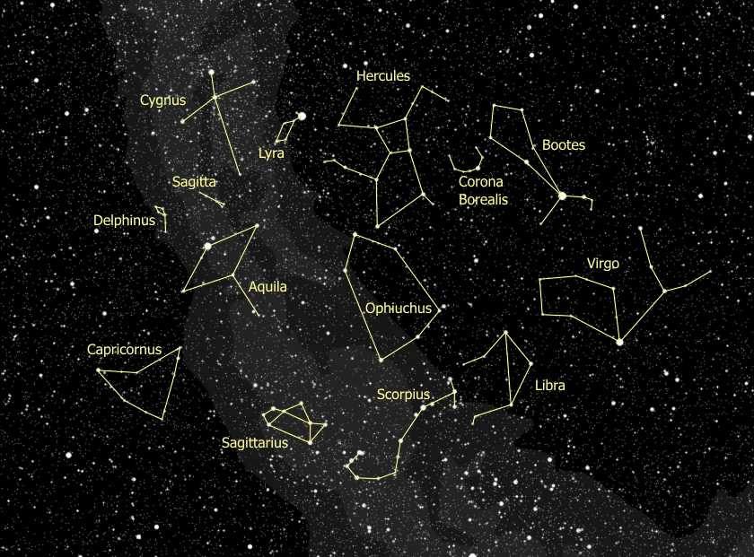

View to the North
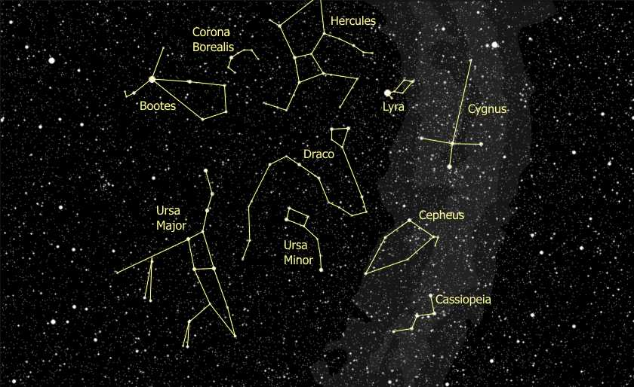

Index to the Tour
Polar Constellations
Boötes
Virgo
Cepheus
Sagittarius
Scorpius
Up the Milky Way
Lyra
Hercules
Draco

Overview of the Tour
The blue arrows map out the basic flow of the tour.
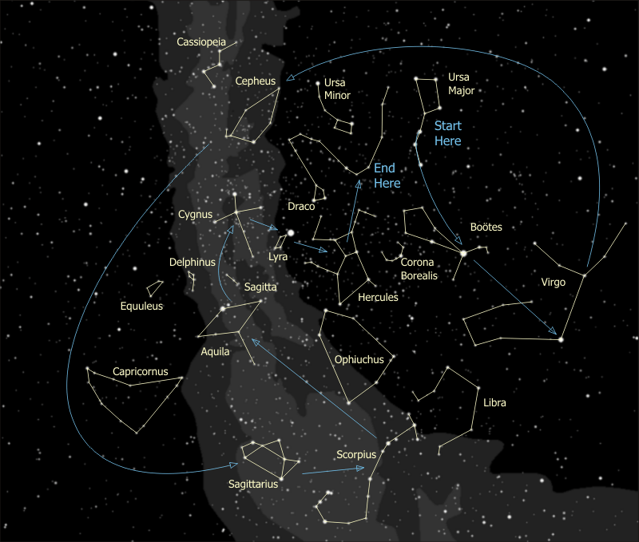

The Top Attractions
Time might be limited, if it's chilly, if conditions are changing, if the bugs are bad or else if time is just limited. In that case, these are the best items to hit - the ones that the kids (and the adults) are talking about days later.
Feature | Naked Eye | Binoculars | Telescope
Mizar & Alcor | ✓ |  | ✓
δ Cephei | ✓
The Scorpion's Claws (Libra) | ✓
The Lagoon & Trifid Nebulae | ✓ | ✓ | ✓
The Coathanger |  | ✓
Albireo |  | ✓ | ✓
The Double Double |  | ✓ | ✓
The Ring Nebula |  |  | ✓
M13 |  | ✓ | ✓

The Polar Constellations
- Anybody recognize anything? (Someone will recognize the Big Dipper). {Trace out the Big Dipper}.
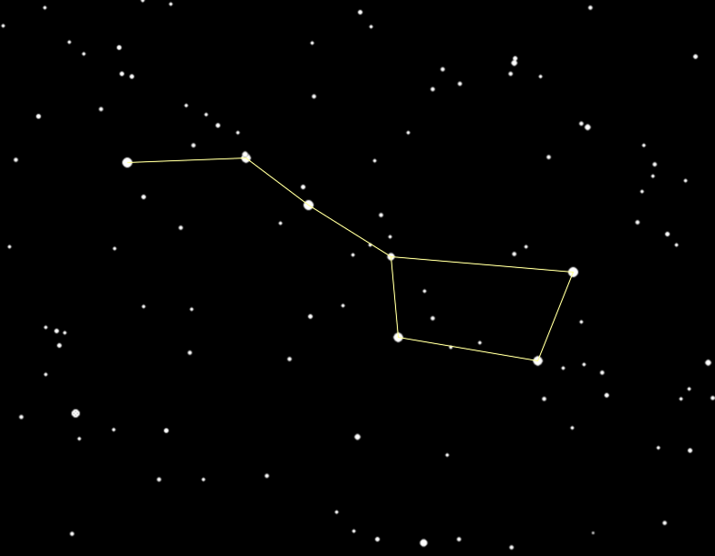
- It's really not a constellation, it's what's called an 'asterism', a highly recognizable part of a constellation. The full constellation actually is Ursa Major. {Trace out as much of Ursa Major as can be seen - later in the summer, the head & paws may not be visible.}
- However - if the tour is being given on a late spring night and the Bear's paws can be seen then I also tell about the Three Leaps of the Gazelle. This asterism is the sequence of three pairs of stars - normally seen as the paws of Ursa Major. The story is that Leo the Lion startled the gazelle, who in turn dashed off across a great celestial pond, leaving a pair of stars marking each of the three leaps. Great story, great asterism, and by July, pretty much lost to the horizon.
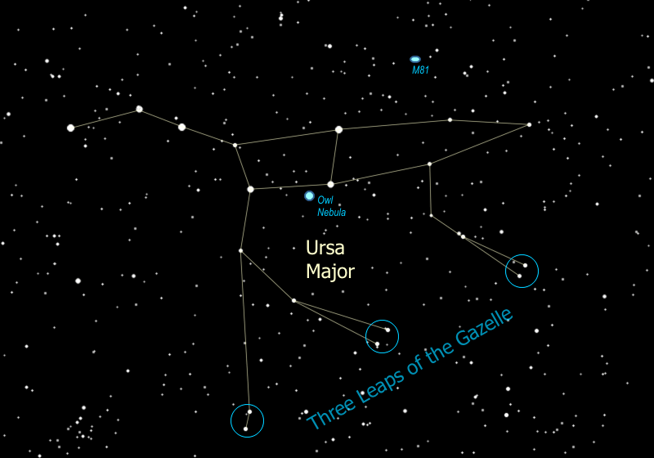
- The stars of the Big Dipper, with the exception of the tip of the handle and the tip of the cup, are all moving in the same direction -- up and to the left, or toward the Northwest. Because they're close together (all are about 75 light years away) and moving through space in the same direction at the same speed, these stars are believed to have formed together from the same original nebula. This group, known as the "Ursa Major Moving Group", is officially the closest star cluster to us, and includes stars that are scattered across the sky all the way from Boötes & Corona Borealis to Auriga and Taurus. The reason they seem to be everywhere is because our 5 billion-year-old sun has drifted into the outer regions of this group of 500 million-year-old youngsters.
- We can find two of the best and brightest galaxies in the sky just above the two stars that form the neck of the Bear -- they are M81 and its neighbor M82. Use the binoculars and follow the line of the Bear's neck to a skinny triangle, then go sideways to find a pair of stars that point the same direction as the triangle does. Just a little farther you find M81, a faint fuzzy spot just off the end of the arc of three faint stars nearby. See it? This faint fuzzy spot is actually a spiral galaxy, 12 MILLION light years away. When I get this one in the telescope you'll see that there are actually two galaxies there. The other one is M82, and it's called the Cigar Galaxy because of its shape -- it looks flatter than M81 because we're seeing it edge-on. M82 is about the same distance as M81, and is called a "starburst galaxy", because the gravity from M81 is causing a burst of new star formation in the Cigar. So even though M82 is only about a third the size of our Milky Way galaxy, it is five times brighter!
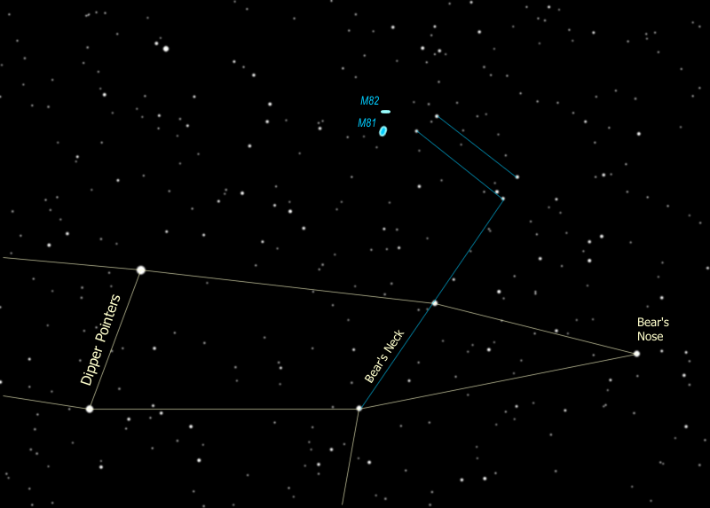
M81 is on the left, M82 is at the right
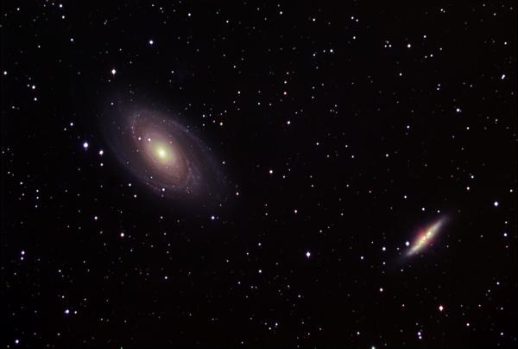

- The Big Dipper is a polar 'constellation' -- one that is very close to the North Pole. If stars are close enough to the pole they never set below the horizon and we can see them all year long. Can anyone spot the Pole Star? How do you find it? That's right, the two stars at the front edge of the cup are pointer stars and point to the North Star, whose actual name is Polaris. Go up from the cup to find Polaris.
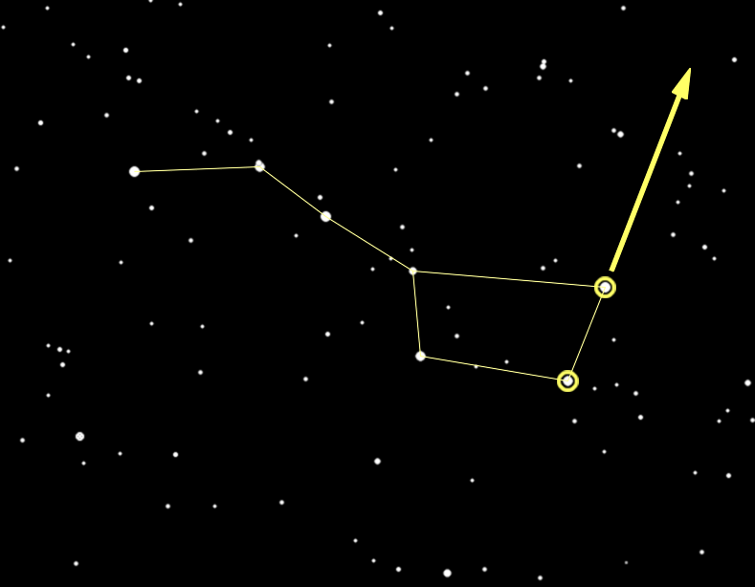
- Since the earth's north pole points to Polaris and the earth rotates around its poles, all the constellations seem to rotate around Polaris, including the Big Dipper. You can tell time using the Big Dipper -- it serves as a 24-hour clock.
Click on the little clock here for more information.
- Polaris is a part of the constellation Ursa Minor, more commonly known as the Little Dipper. Polaris is at the tip of the handle. {Trace out the Little Dipper.}
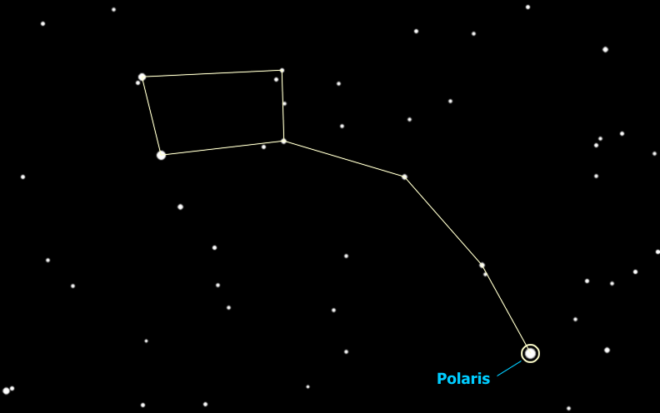
- The two most important Polar Constellations to recognize are the Big Dipper and the Big W. The Big W is Cassiopeia - roughly on the opposite side of Polaris from the Big Dipper -- {Trace out Cassiopeia}. Cassiopeia is a Queen in her chair, and even though this isn't the "official" way to look at her, I envision Cassiopeia's head at the left side of the "W", making the figure like a lounge chair with a foot rest. This is how I learned it as a kid, and it's very useful because you can easily find the North Star by going "Up from the Seat" of Cassiopeia's chair, in similar manner to going "Up from the Cup" of the Big Dipper. Since the Big W is on the opposite side of the North Star, this gives you a way to find Polaris any time of the year, even when the Dipper is below the tree line.
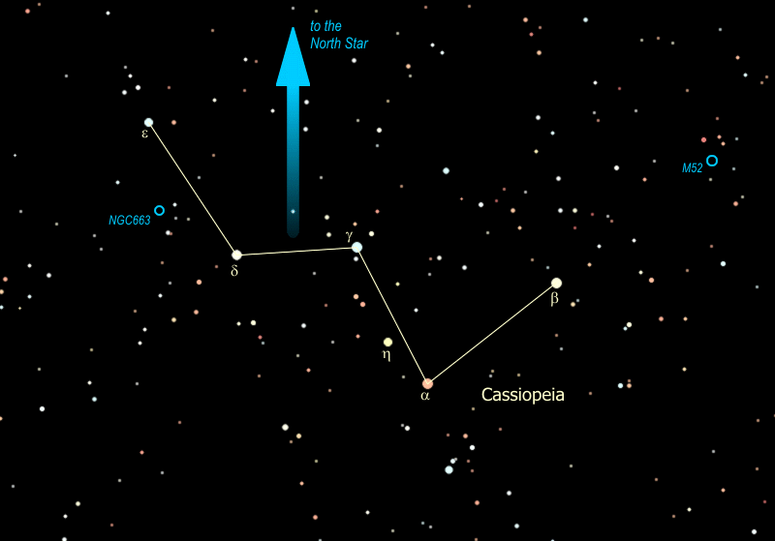
- Cassiopeia got herself in trouble with Poseidon boasting she was more beautiful than the Nereids (sea nymphs) which leads to the story of Andromeda and Perseus and involves no less than six constellations in the sky (all fall constellations), the most involved in telling any constellation legend. That's a story for another season.
- The constellation Cassiopeia lies right smack in the path of the Milky Way, and is filled with galactic clusters, also called open clusters. There are several decent examples in Cassiopeia, like Messier object #52, or "M52", one of many "M" objects named after a catalog published in the late 1700's by the Frenchman Charles Messier. Messier was a comet hunter of great renown who published a catalog of fuzzy things that might be confused with comets. These ended up being some of the most interesting objects in the sky. When you find M52 you are looking at a "young"cluster of about 200 stars -- young means that it is only about 100 million years old. The cluster is 10 light years in diameter and 3000 light years away from us, which is why you need the binoculars to see it.
Another interesting galactic cluster is NGC 663 (NGC stands for New General Catalog -- published in 1888 it's not really that new). This cluster lies about half way between the two stars on the flattened side of the "W", e and d Cassiopeiae. As you sweep the binoculars between the two stars, you will notice that NGC 663 is merely the largest and brightest of several clusters in this region. That may be because it is the closest, at about 3000 light years. The others in that area are 6000 - 8000 light years away. How many clusters can you spot between these two stars? You might be able to see as many as five, with NGC 663 at the center and the other four marking the corners of a diamond around it.
M52 - Note the little box of stars around the cluster | NGC 663 - halfway down the left side of the "W"
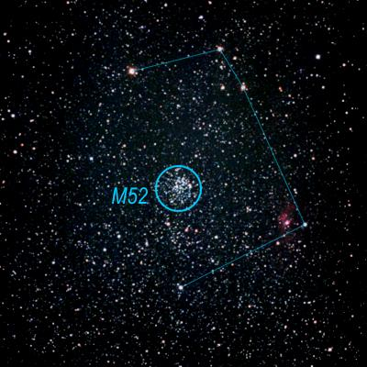 | 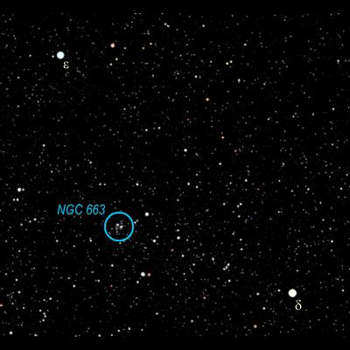

- So the Big Dipper points to the North Star -- it also points to other important stars -- you follow the arc of the Dipper's handle and "arc to Arcturus", then "spike to Spica" - two very important stars that we will get to in a minute. So the three stars of the handle are pointers as well.
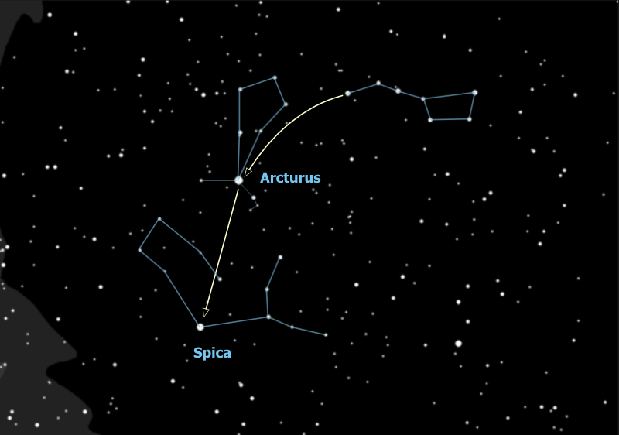

- Wait a minute is that really three stars in the Dipper's handle or is it four? Looky there the middle star seems to have a companion -- the bright star is Mizar and the companion is Alcor. Who can see the companion?
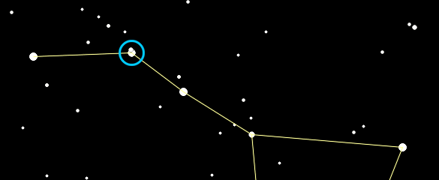
That was used by ancient Greek and Arab armies as an eye test. Some see them as a horse & rider. The Europeans saw the handle of the dipper as the tail of the Great Bear. Since bears don't have tails they danced around it by explaining that when the gods lifted the bear to the sky the tail got stretched out. Pretty lame. The Indians, who knew darn right well that bears don't have tails, saw the three stars of the handle as hunters chasing the great bear (interesting that they also saw a bear). When the constellation Ursa Major sets in the fall, the Indians explained that the hunters catch up with him and shoot him with their arrows, which is why the leaves on the trees turn red. Anyway the three stars are hunters and one of them brought his dog, so Mizar is a hunter and Alcor is his dog. Or another story is that there are three hunters pursuing the bear and one brought a pot to cook the bear in (optimistic). So Mizar is a hunter and Alcor is his pot. Yet another story involves the Pleiades. This is a star cluster in the constellation Taurus (a winter constellation). It is called "the Seven Sisters" and those with very sharp eyes can see seven stars but most people can only see six. So the story is that Mizar is riding off with the Seventh Sister.
But wait there's more! When we put the telescope on these two you'll see that Mizar is really a double star itself! So these three form a triple star. But wait... that's right... there's MORE! In reality each of the two stars that make up Mizar is a double star, too close for us to see even with a big telescope, and for that matter, so is Alcor! So Mizar & Alcor comprise a SIX STAR SYSTEM!!

The Constellation Boötes
- We will now follow the handle of the Dipper and arc to Arcturus, a star in the constellation Boötes (pronounced boo-OH-teez). {Trace out Boötes}. Boötes is a herdsman and the Guardian of the Bear -- Ursa Major. It is usually pictured as a guy just standing there, somtimes with a staff -- you can make the hook of the staff out of the three stars to the north of the kite, just off the end of the Dipper's handle.
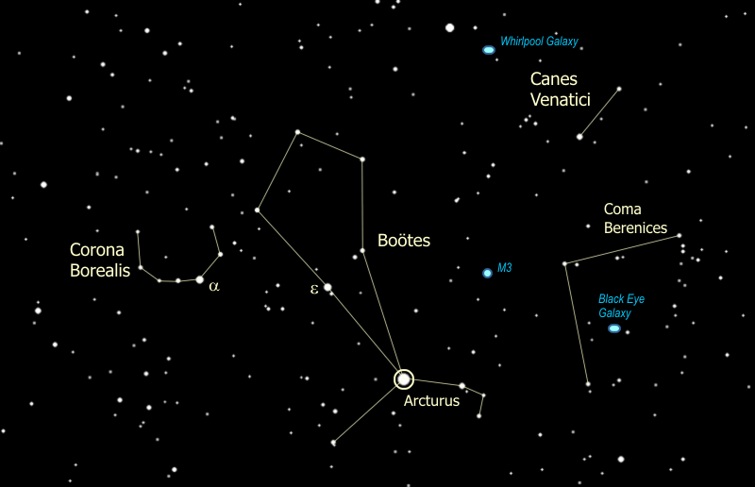
Arcturus is historically famous for a number of reasons. For example it was used to turn on the lights at the 1933 Worlds' Fair in Chicago. They put a telescope on Arcturus, focused the light down to a photocell which then turned on the lights. The reason they did this is that Arcturus is 40 light-years away from us, and the last time the World's Fair had been in Chicago was in 1893, 40 years prior, so the light they were using to start the World's Fair had left the star at the time of the last World's Fair in Chicago. Cool, huh?
Note to the tourguide: when it gets late in the summer and I can no longer effectively use Spica for star brightness & color, I base it on Arcturus starting with the above story, then proceed as follows: They also used Arcturus because it is so bright. What do you think, is Arcturus the brightest star in the sky? Is there any brighter? (The group will find Vega.) Right, that's Vega, and it may look brighter because it's higher in the sky. Technically Arcturus is brighter but they are virtually the same. -- Then go on to point out Altair & Deneb as 1st magnitude stars & Polaris & Dipper as 2nd magnitude examples, then the whole discussion on magnitudes. I then have the group compare Arcturus and Vega for "anything else that's different" to get to star color. By pointing out yellow Dubhe & blue Alkaid and going on to their exclusion from the Ursa Major moving group I get a nice transition back to Corona Borealis.
- Next to Boötes is Corona Borealis, the northern crown. {Trace out Corona Borealis}. The brightest star is α (alpha) Corona Borealis. This star is part of the Ursa Major Moving Group -- the same moving star group as the stars of the Big Dipper!
- To the right of Bootes, just below the handle of the dipper, you can see two stars. The brighter one is called "Cor Caroli" -- it means the heart of Charles (King Charles II). These two stars form the constellation Canes Venatici. If you look carefully you can pick out two faint, scraggly diagonal lines of stars, one of which includes the two stars I just pointed out and the other is just a little above it. These two lines are two dogs on a leash held by Bootes -- come on, use your imagination -- and are helping him in his duties as herdsman and guardian of the bear.
Cor Caroli is a member of a huge asterism known as "The Diamond of Virgo", which goes from Cor Caroli to Denebola, the easternmost bright star of Leo, to Spica in Virgo, to Arcturus in Boötes, back to Cor Caroli. See it? Isn't it huge?
- Note Boötes is a kite-shaped constellation. It used to be a shorter kite -- in ancient Greek & Roman times (2,000 years ago) Arcturus was half the distance closer to the two center stars (epsilon & rho Boötes). It is moving across the sky faster than any other bright star (except Alpha Centauri which is ten times closer) -- it couldn't be seen 500,000 years ago and 500,000 years from now it won't be visible any more. Why is Arcturus moving so fast?
The stars of our galaxy are formed into a rotating disk and are all moving together around the disk. Some stars -- called "halo" stars -- form a dome over the disk, Arcturus is one of those stars, orbiting above and below the galactic center. It is cutting through the disk now, actually a little bit back against the general flow. Someone on a planet orbiting Arcturus would see the entire night sky changing constantly.

The Constellation Virgo
- We now Spike to Spica. This is part of the Zodiac constellation Virgo. {Trace out Virgo}. This is a faint constellation, close to the horizon at this time of year and a little hard to see.
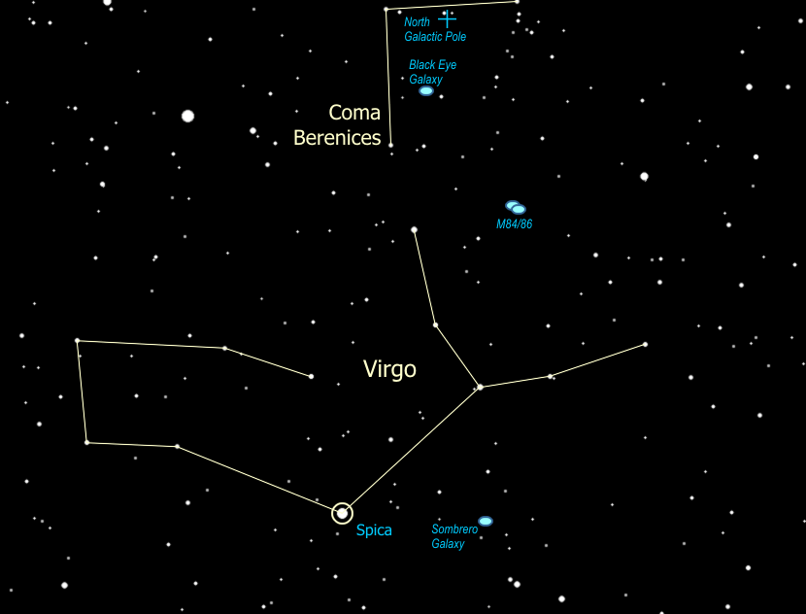
- Just above Virgo, if you look very hard, you can see a faint, wispy grouping of stars that looks a bit like a tuft of hair. Can you see it? In fact that is a star cluster, and together with the three nearby stars that form a right triangle, they are the constellation Coma Berenices, or "Berenices Hair". {Trace out Coma Berenices, showing the right-angle stand and the hair hanging from it}. The cluster is a true family of stars that were formed together, and it is "only" 250 light years away. This means that only the Ursa Major moving group and the cluster that forms the face of the winter constellation Taurus are closer to us.
- You can see how the western stars of Virgo and Spica form a "Y" figure. I see the "Y" as being her arms, although others see the 'left arm' as being her head & Spica as her left hand holding a grain of wheat.
- I prefer to think of her arms outstretched holding the Virgo Cluster -- not a cluster of stars but rather a cluster of galaxies. The galactic pole of our galaxy is right in Coma Berenices (you are looking up out of the disk) and hence that is the best direction to see out of our galaxy and spot other galaxies. The Virgo cluster is an actual cluster of galaxies (100 bright galaxies, over 2,000 fainter ones), close to each other in space.
This region of interesting galaxies sweeps right up through Coma Berenices and is often called the "Virgo-Coma Cluster". One of the best is the Black Eye Galaxy, just to the left of that little star right there {point out 35 Comae}. You can spot it with the binoculars, although we need a relatively large telescope (8" or better) to see the black eye at the center. It's actually a lane of dust that is the result of a collision with another galaxy -- literally smacking into this one and leaving it with a black eye.

- I called Virgo a Zodiac constellation. What is a "Zodiac" constellation?
As the earth goes around the sun, this motion means that every day we look back at the sun in a slightly different direction, with different stars behind it. The sun appears to move through the constellations. Theoretically there are twelve constellations through which the sun moves, one per month, and these are the Zodiac constellations. In reality there is a 13th constellation through which the sun passes (technically at least) and it gets no credit for being in the Zodiac - Ophiuchus.
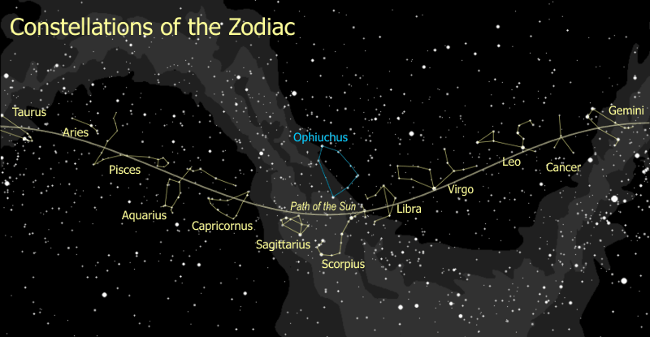
- Clearly the brightest star in Virgo is Spica. Which do you think is brighter, Spica or Arcturus? Which is brighter, Spica or Polaris?
Astronomers measure star brightness using 'magnitudes' -- Arcturus has a magnitude of 0, Spica has a magnitude of 1, Polaris has a magnitude of 2. As magnitude number goes up, brightness goes down. A magnitude 1 is 2½ times as bright as a magnitude 2, a 2 is 2½ times as bright as a 3, and so on.
This comes from the system set up by ancient Greeks, where the brightest stars were stars of the first magnitude, like 'first class', and the faintest stars you could see were stars of the sixth magnitude. When astronomers got telescopes and instruments that could measure star brightness, they found 1st magnitude stars were almost exactly 100 times the brightness of 6th magnitude stars. That works out to a factor of 2½ from one magnitude to the next.
Magnitudes can go negative for stars brighter than 0 magnitude Arcturus. The brightest star in the sky is Sirius (in the winter sky), which has a magnitude -1.5.
Well, what's really the brightest star in the sky? The sun has a magnitude of -27.
- You can use the cup of Little Dipper to gauge how good your sky is... the clearer the sky, the fainter the magnitudes you can see. The North Star, at the tip of the handle, is magnitude 2, as is the next brightest star at the tip of the cup (b Ursa Minoris) -- also magnitude 2. The other star at the end of the cup is magnitude 3. The star where the handle joins the cup is magnitude 4, and the other star at the back of the cup is magnitude 5. You can only see the magnitude 5 when the sky is very clear and very dark. Exactly half-way between the magnitude 4 and 5 is a magnitude 6, at the limit of what most people can see. You may need to use "averted vision" to see it -- look at the first star of the handle and, as you look away from the cup, you can see the faint magnitude 6 star at the back of the cup, the sign of an exceptionally clear and dark sky. The Little Dipper test works best in the summer when the Little Dipper is highest in the sky.
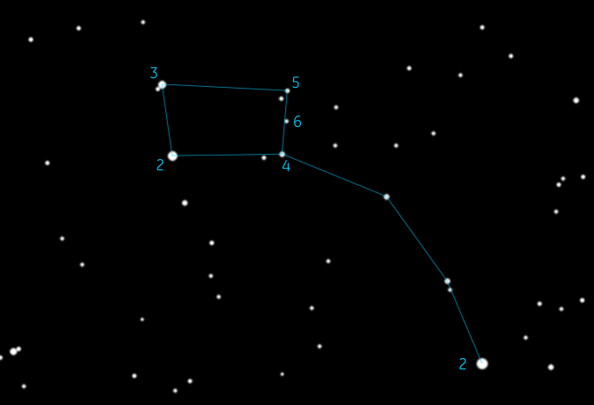
- It's not only the brightness of each star that is different. Can you see a difference in color between Spica and Arcturus? Look at Arcturus and tell me what color that might be. It's more yellow than Spica, isn't it? Spica is more of a blue color. That very bright star to the south is Antares (part of the constellation Scorpius). The name "Antares" is from Greek and means "rival of Mars". Can you see why? It's every bit as red as Mars, isn't it? So what do the star colors mean? Why would one star be blue and another red?
Yup, that's right. Different colors show different temperatures. So which star color is the hottest? Just like a flame, blue is the hottest part, yellow is next, red is the coolest. The sun is a yellow star, about 10,000°F at the surface. A red star is about half the sun's surface temperature, whereas a blue star is three to five times as hot as the sun. White stars are somewhere between the yellow ones and blue ones.
Now, all stars are made of pretty much the same stuff -- about 90% hydrogen and the rest is helium with some traces of other stuff. So, why would one star be burning hotter than another? The answer is in the size of the star. The more massive it is, the more pressure there is at the center and therefore the hotter - and for that matter the brighter - the star burns. So blue stars are the biggest and brightest of stars, and red stars are the smallest and dimmest.
So why is red Antares so bright? Hmmm... yeah... well, like with most rules, there are exceptions to the rule, and this rule is no exception. Antares is a star that is literally running out of gas. As a star burns up all the hydrogen at its center, it starts to burn helium (which is the "ash" from the hydrogen burning), which makes it expand, get brighter, and turn red -- it becomes a red giant. This is the time you can get a bright red star, when the star is near the end of its life.
When our sun starts burning out it will expand so big it will swallow up Mercury and Venus and scorch the surface of the earth to a cinder. If you are hoping to see all that happen you will have to wait about 5 billion years.
So there are two reasons a star could be red -- it is massive (and once was yellow, white or even blue) and is now burning out (a red giant), or it never had enough mass to burn any hotter than red (a red dwarf).
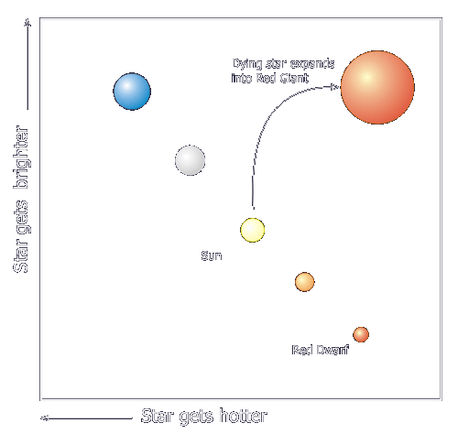
Notice that when we graph out the stars showing their temperature (or color) against their brightness, most of them fall along a line -- this line is called the Main Sequence, and the graph is called the "H-R" (for Hertzsprung-Russell) Diagram. Others are not on the main sequence, mostly stars that are either just being born (called "T-Tauri" stars) or stars that are near the end of life.

The Constellation Cepheus
- The reddest star in the sky is μ (Mu) Cephei, "The Garnet Star" in the constellation Cepheus. {Trace out Cepheus.} Cepheus is a king, and Cassiopeia is his queen.
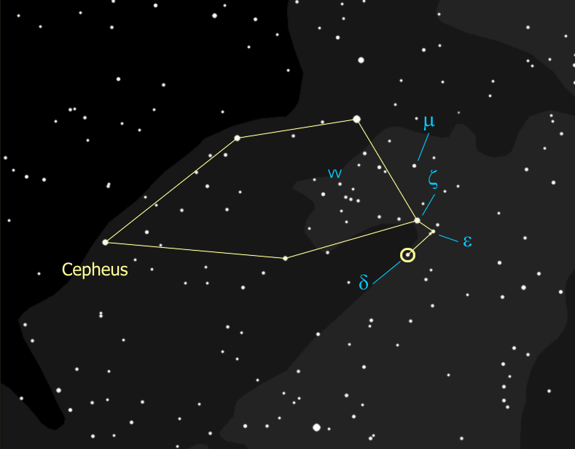
- Cepheus is sort of a house-shaped constellation, and μ (Mu) Cephei is located halfway between the two stars at the bottom of the house. It is a red super-giant, 1,500 times the size of the sun. It was considered the largest star known to man until just recently when 3 other stars (which you can't see without a big telescope) were measured about the same size but just barely edge it out. Placed where our sun is, the surface of m Cephei would extend out past Jupiter. To really appreciate how red this star is, it sometimes helps to use the binoculars (or the telescope).
- Another star in Cepheus is of crucial importance to astronomy -- δ (Delta) Cephei. {Locate δ Cephei.} This star is a "variable", meaning the star's brightness varies over time -- in this case it varies between that of ζ (zeta) Cephei and ε (epsilon) Cephei over a period of five days. How bright is it now -- as bright as ζ, ε, or in between? We will assess again each night that we can during the week.
- This star was the first of its type to be discovered, hence these variable stars are called 'Cepheid' stars. Their discovery, as it happens, rocked the astronomy world. So what's the big deal?
Cepheid stars have gotten to just the right mass to be unstable - so the whole star is pulsating, the surface of the star is actually rising and falling, with a rhythm that is so precise you could set your watch to it. It was discovered in 1912 that this rhythm depends directly on the true brightness of the star -- the brighter the star, the longer the time between peaks.
Now when a star is closer to us, it seems brighter. When it's farther away it seems dimmer. So if we know the true brightness of the star, and we measure its apparent brightness, we can figure out the distance of the star. If the star is part of a cluster or a galaxy, this tells us the distance to that entire body of stars. This has been used to find the distances to globular clusters, other galaxies and even our distance from the center of our own galaxy -- 28,000 light years.
In 1924, Edwin Hubble (yes, the telescope is named after him) used Cepheids to measure the distance to the Andromeda 'nebula' (2.3 million lightyears) and proved that it is not another solar system in formation but an 'island universe', another galaxy like our own. This was an extraordinary declaration about the structure of the universe back in 1924. Our whole system of measurement of the universe is built upon the Cepheids as our basic yardstick.
- Then on top of all that, if we look in the telescope we can see that bright yellow δ Cephei has a beautiful blue companion -- so this is both a variable star and a binary! The yellow star is the variable component, and once was a blue star like its companion. It is now expanding out as it goes through the end-of-life process, and is passing through an unstable phase as it does so. The pair is about a thousand light-years from us, based on the Cepheid period-brightness relationship.
Yep so that's how we figured out how far we are from the center of our galaxy. We're looking in the wrong direction to see the center of our galaxy. For that we need to swing around to the constellation Sagittarius -- to the south -- which is our next stop on the tour.

The Constellation Sagittarius
- The center of our galaxy is located to the South, in Sagittarius. You can't see the entire constellation of Sagittarius but you can see the key asterisms, the Teapot & Teaspoon. {Trace out the Teapot and the Teaspoon.}
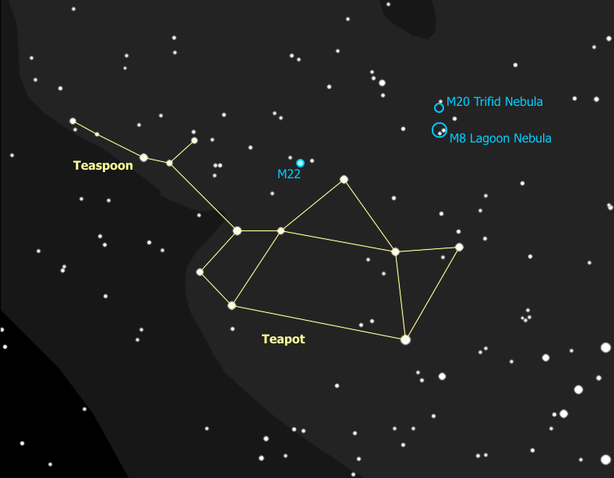
Sagittarius is our second Zodiac constellation. It is an archer that is a centaur -- getting ready to shoot the giant scorpion next to him. The front of the teapot is his bow and the tip of the spout is the tip of his arrow. The rest of the constellation doesn't look anything like an archer or a centaur. Not a problem - people only reference the Teapot in Sagittarius, just as they talk about the Big Dipper, instead of Ursa Major.
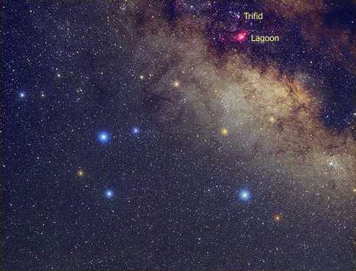
- The bright region of the Milky Way that looks like steam coming out of the spout of the Teapot marks where the center of the galaxy is, about 30,000 light years away.
- If you look at the top of the spout through binoculars then slowly scan up from there, you will come across the Lagoon Nebula (M8) and then the Trifid Nebula (M20). These are diffuse nebulae - clouds of dust and hydrogen gas - the stars you see in them are formed from the gas when it condenses together and compresses due to gravity then, under pressure, heats up and ignites. Nebulae like these, then, are the birthplaces of stars.
This region of the sky, Sagittarius and its neighboring constellations, happens to be one that is dense with nebulae and young stars. The only other region of the sky with this much new-star formation activity is Orion and its neighboring constellations.
Lagoon Nebula in Long-Exposure Photograph | Trifid Nebula in Long-Exposure Photograph
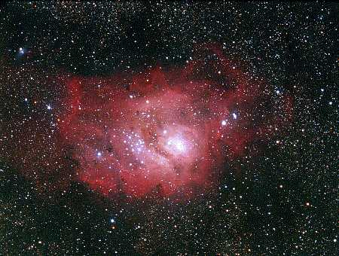 | 

- If you put the binoculars right on the star at the top of the teapot, and slide to the left until the star is at the right edge of your field of view, then right in the center you will see a smudge of light. This is M22, and in a telescope you can see this is a dazzling ball made up of a half million stars, 9600 light years away. It turns out that this is pretty close for a globular cluster.
M22 is the closest Globular Cluster we can see.


The Constellation Scorpius
- Scorpius is a scorpion, a constellation that dominates the summer sky, and, unlike Sagittarius, looks exactly like what it's supposed to be. {Trace out Scorpius, noting Antares at its heart}. This is your third Zodiac constellation.
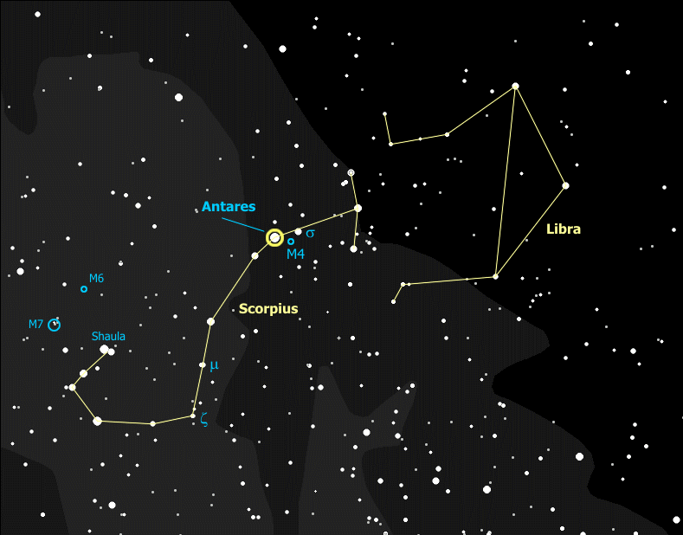
Remember the red star Antares which is the heart of the Scorpion - Antares is a red super-giant and it is a first magnitude star. There is only one other red super-giant that is this bright and it's on the opposite side of the sky, in the constellation that dominates the winter sky -- the star Betelgeuse in the constellation Orion. Both stars are about 500 ly away in opposite directions so we lie just about halfway between the two. Such stars are rare -- there are only 200 known red super-giants and all are much dimmer, most are much farther away than these two stars.
Even though it is a red super-giant near the end of its life, Antares is actually a very young star, at least compared to the sun. Antares was born only about 20 million years ago, long after the Dinosaurs died out, and is nearly at the end of its life already. This is because Antares is so much more massive than the sun. The greater mass causes greater pressure and forces the star to burn hotter (bluer) and faster. So Antares was once a blue supergiant with 12 times the mass of the sun, burning 6,000 times as fast as the sun. Its life as a star will only be about 2 thousandths as long the sun will live. With stars, the bigger they are, the harder they fall.
- The scorpion used to be a much bigger constellation. The two brightest stars of Libra - your fourth Zodiac constellation, have Arabic names that mean "Northern Claw" (Zubeneschamali) and "Southern Claw" (Zubenelgenubi). Say those real fast five times. {Trace out Libra. Trace out the scorpion's claws.} The Romans cut off the scorpion's claws and created a new Zodiac constellation to fit their new, 12-month calendar. The constellation Libra represents a balance scale, with the top of the balance to the west (your right).
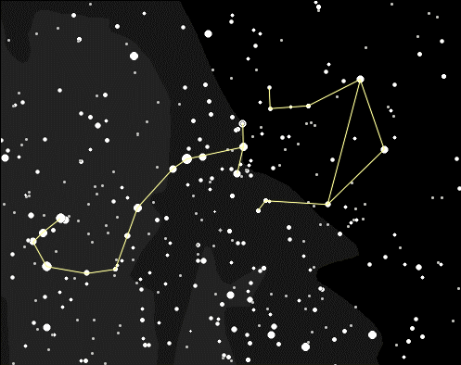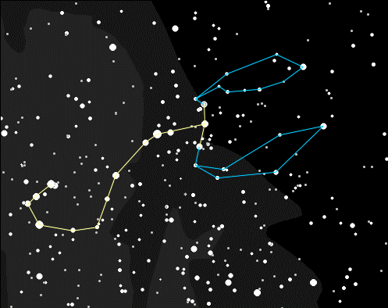
If you look at the Southern Claw in the binoculars you will discover it is actually a double star -- a true double star -- they are the same distance of 75 light years away and moving together. If you have good eyes you may be able to see both stars without the binoculars. Meanwhile if you look at the Northern Claw in the binoculars you see what many people call the only green star visible to the naked eye. What do you think? Is this star really green?
- Tracing down the scorpion's back with binoculars you can find a lot of great objects. M4 is a globular cluster about halfway between Antares and σ (Sigma) Scorpii, the bright star just to the West. M4 appears in the binoculars as a faint ghostly presence, which almost looks painted onto the sky between the two bright stars.
μ (Mu) Scorpii is a double blue star, a true pair almost a light-year apart. South of μ is ζ (Zeta) Scorpii, a visual double, not a true double (very close to the horizon, difficult to see even with binoculars). The eastern, brighter star is an orange giant about 150 light years away. The western star is a blue super-giant estimated to be 5700 light-years away, one million times as bright as the sun - a candidate as possibly the most massive super-giant known. Just above ζ Scorpii is a beautiful open cluster, NGC6231. The bright star at the tip of the scorpion's tail is Shaula, a brilliant blue star about 310 light years away.
NGC6231 is called the "Northern Jewel Box".
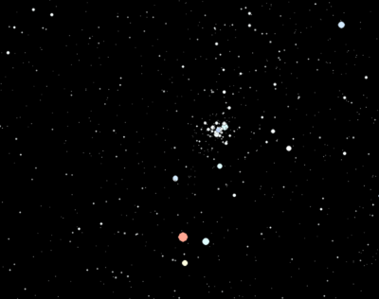
- Above and to the east of Shaula you will find two "open clusters", M6 and M7. Open clusters, also called 'galactic' clusters, are small groups of stars, maybe a hundred or so, that formed from the same (huge) cloud of gas and dust. They are very often young stars - blue ones which are large and very hot and don't last long.
These two clusters are good examples, most of the brightest stars are blue ones. Groups like this eventually break up, mostly by random events, (our sun has left its original cluster) so when they are still together like this it's another sign that the cluster is young.
M6 is sometimes called the "Butterfly Cluster" because it looks like a butterfly with its wings open (flying toward the Northwest). Can you see it in the telescope? You may even be able to spot the butterfly's antennae. Can you spot the orange giant among the hot blue stars? M7 is more spread out (it's closer) - it can be seen perfectly well with binoculars and can even be spotted with the unaided (sharp) eye.
M6 Butterfly Cluster | M7
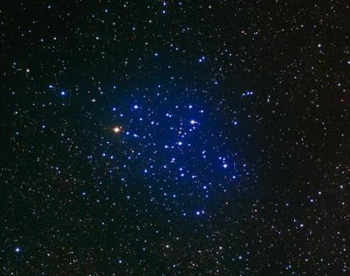 | 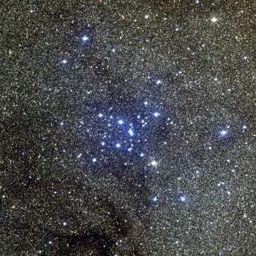
- That great, empty part of the sky just above Scorpius actually is a constellation, it's called Ophiuchus and it's kind of coffee-pot shaped. {Trace out Ophiuchus} It isn't Ophiuchus the Coffee Pot, though, it's Ophiuchus the Serpent Bearer, and the Serpent is there, too, with the name of "Serpens". No, I'm not making this up as I go along. Serpens is an odd constellation, treated as a single constellation but it's split into two parts -- the head of the serpent, called Serpens Caput, {trace out Serpens Caput} and the tail of the Serpent, called Serpens Cauda {trace out Serpens Cauda}. This has been recognized as a constellation for over 4,000 years, as a great giant wrestling a serpent. And by golly, with a little imagination you can just about see it. Well I can.
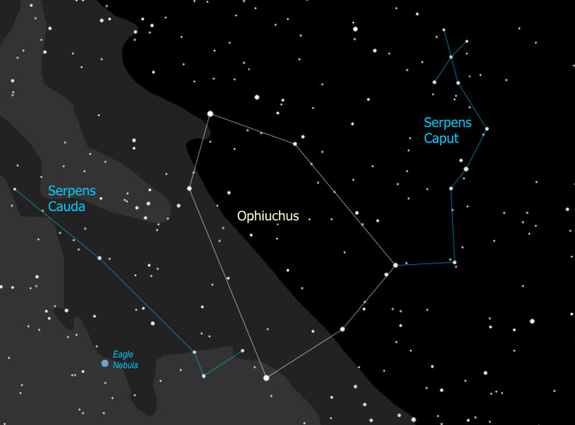

Up the Milky Way
- Note - we might have this discussion any time during the sky tour, whenever it comes up.
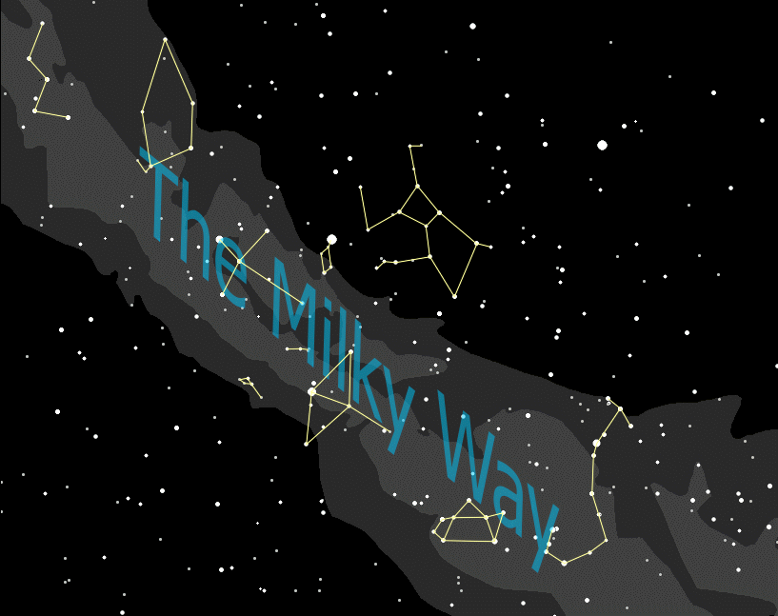
You can see the Milky Way on any clear summer night, but up in the north woods, on especially clear nights, the Milky Way glows like a neon light, from north horizon to south horizon, brilliantly reflected in the lake by our camp. Most people recognize the Milky Way as a band of light across the night sky, but what is that band of light - where does it come from?
- Well it's a bit like looking at a gravel road. Close to you, you can see individual stones, while off in the distance the road merges into a uniform gray. When you look at the Milky Way you are looking at the disk of our galaxy from the inside - the nearby stars you can see individually (most are less than 1,000 light years away), the distant stars merge into a hazy glow. So when you see that band across the sky you are really looking way off into the distance, into the "billions and billions" of stars that make up the disk of our galaxy.

You'll see a similar phenomenon later when you look at the M13 globular cluster in Hercules. Through binoculars you will see it as a hazy patch. When you see it through a telescope - that is, closer up - you can pick out individual stars. The better the telescope, the 'closer' you can get to M13, the more stars you can see.

- We can find some more constellations -- some of the best -- by following the Milky Way up from Scorpius and Sagittarius. First we come to Aquila the Eagle. {Trace out Aquila.} The bright star is Altair, and the two stars on either side of Altair are called the Pilot Stars. Altair is 16 light years away. It's about half again as big as our sun and nine times as bright. That shows how sensitive stars are to mass -- just a little more mass causes the star to burn much brighter.
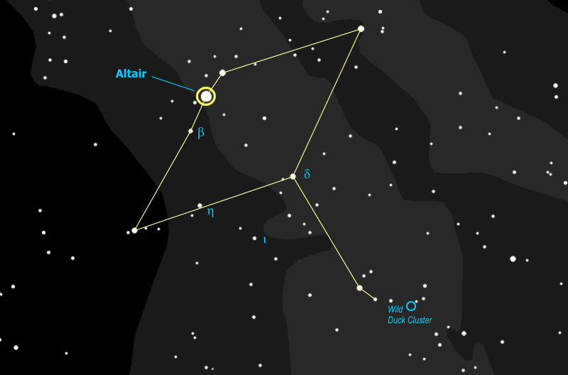
The star that is about halfway between Aquila's eastern wingtip and his body is called η (Eta) Aquilae -- and this is another Cepheid variable with a cycle of about 7 days. At its brightest it's nearly as bright as the body star, δ (Delta) Aquilae (actually it's as bright as the eastern Pilot Star β Aquilae), and at its dimmest it's about as bright as ι (Iota) Aquilae. This is one of only three Cepheids you can see by eye - you already met δ Cephei, the original, and the third one is in the winter constellation of Gemini.
- If you look with the binoculars you can find the two stars of Aquila's tail, then slide west (to the right) until they are at the far left of the field of view. To the far right of your field of view you can now see a fuzzy spot with a star at the center - you have found the Wild Duck Cluster. In a telescope this looks like a dense cluster of tiny stars broken into groups - the central group is V-shaped and looked to early observers like a flight of wild ducks - hence the name.
- The next constellation we reach is Cygnus the Swan. {Trace out Cygnus}. This constellation is also known as the Northern Cross and at Christmas time, in the evening, it has rotated across the sky so it is standing on its base on the northwestern horizon, with the bright star Vega next to it. Very Christmas-y.
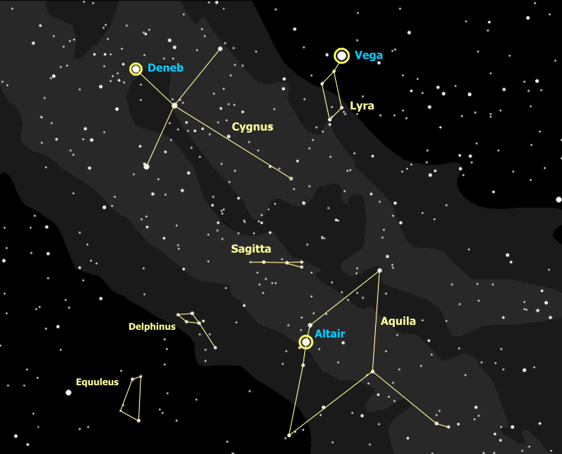
Deneb is the star at the tail of the Swan. Notice that it is about as bright as Altair, which is 16 light years away -- so how far would you guess Deneb is? As it happens... Deneb is 2600 light years away - about 150 times farther!! Deneb is actually 20,000 times brighter than Altair and 200,000 times brighter than our sun. If Deneb were as close as Altair, it would be visible in broad daylight and would cast a shadow at night. This star is one of the greatest super-giant stars known.
Notice in the picture above that Altair and Deneb are two of the three bright stars overhead, which form the "Summer Triangle". You will be introduced to the third (Vega) in just a moment.
Albireo, the star at the head of the swan, is actually a beautiful double star, a yellow giant and a blue main-sequence star. You can just split this star with good binoculars held steady, and it looks better in a telescope.
- You can use Cygnus (the Northern Cross) as a gauge of the sky, in similar fashion to the Little Dipper, but with Cygnus at a higher elevation, you can check the sky at its very best. Use the western wing of Cygnus, starting with Deneb as a magnitude 1, and going around counterclockwise to the body star at magnitude 2, the wingtip at magnitude 3, and a pair of stars on the back edge of the wing at magnitude 4. Just off the wingtip is a magnitude 5 star - if you can see it, you have an excellent clear, dark sky. Half-way between the wingtip and the pair of magnitude 4's is a magnitude 6, which you can only see under the very best conditions.
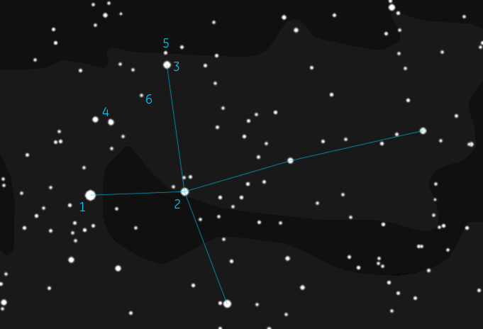
- The Milky Way looks like a single solid band as you follow it from Cassiopeia through Cygnus to Sagittarius, but this is misleading. When you look at the "steam" above the spout of the Teapot in Sagittarius, you are looking toward the center of the galaxy but you are not actually seeing the center of the galaxy. You are actually looking at the great, massive spiral arm next to ours, the next one in toward the center. You go through this spiral arm, past lanes of dust, and through two smaller spiral arms before you finally reach the center. When you look at Cygnus, you are looking right down the beam of our local spiral arm, which is really just a tiny branch off the Sagittarius arm. Then when you look at Cassiopeia, you are looking at the great massive spiral arm that is just outside ours. Beyond that arm lies one more final wisp, and beyond that... the rest of the universe.
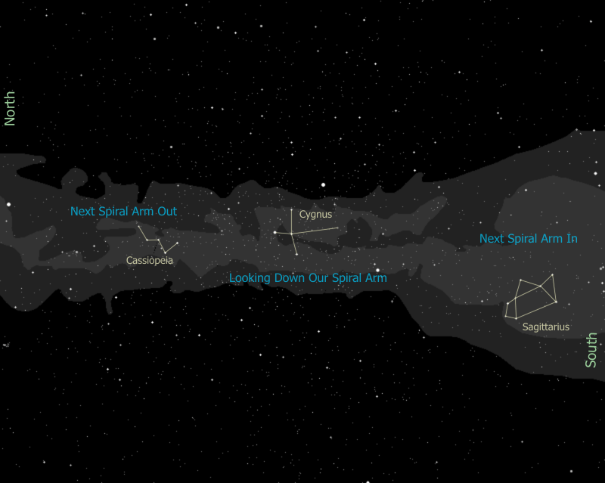
Note that you can see how this all lays out, looking down on the galaxy, in the latest Milky Way diagram to come from NASA, based on new Spitzer Telescope observations.
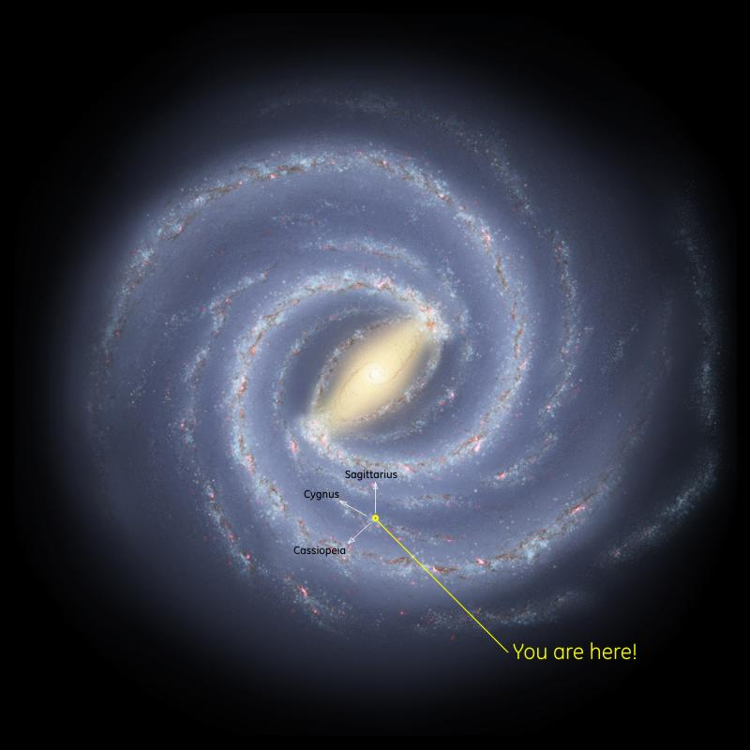
- Just above and to the east of Aquila you can spot a small diamond of stars with a little tail coming down. This is the tiny constellation, Delphinus the Dolphin. It really looks like a little dolphin, doesn't it?
- Then next to Delphinus, continuing to the left (east) is another teeny tiny, and faint constellation, Equuleus the Horse. It's four stars forming a horse's head, with the nose pointing up, to the North. See it? Actually it's five stars, the corner by his jaw is a pair of stars. Equuleus is in competition for "Smallest Constellation in the Sky" -- only the Southern Cross, next to the South Pole, is smaller, by just a sliver.
- The two birds, Aquila the Eagle and Cygnus the Swan, are flying straight at each other and, to enhance the suspense, Sagitta the Arrow flies between them, just missing both. {Trace out Sagitta.} What is most interesting about Sagitta, though, is not so much the constellation as the features for which it is a milestone. (Note: these two features, technically, are in the neighboring and very faint constellation "Vulpecula" the Fox.)
If you locate the two tail-feather stars of Sagitta in binoculars then follow the line between them up (to the northwest), just one field of view, you will see the Coathanger, an interesting cluster of stars.
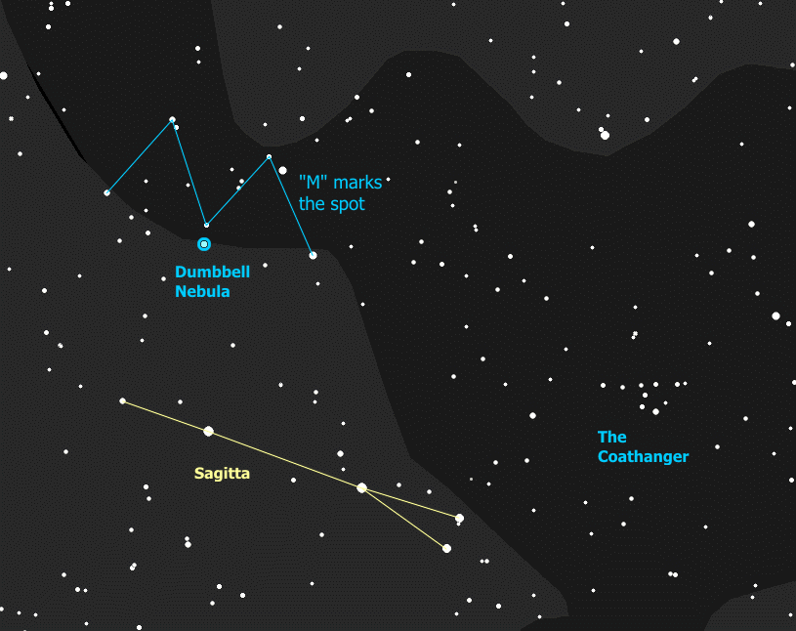
If you are really good with those binoculars you can go up from the tip of the arrow, toward Albireo in Cygnus, and you will find a group of stars that just fill the field of view in the shape of an "M". Right at the central point of the "M" is a faint fuzzy patch that actually is known as the "Dumbbell Nebula". To really see its hourglass shape requires a telescope. This hazy patch once was a star, until it blew itself apart.
This is called a "planetary nebula", because the typical disk shape (this one is less typical) suggested the look of a planet to early astronomers. In fact it has nothing to do with planets at all. This is what's left of a red giant star that finally did what all red giants eventually do. When the fuel at the core runs so low that the nuclear reactions can no longer hold up the weight of the star, it all collapses in to the center, which in turn raises the temperature so high that the star blows off its outer envelope of gases, losing much of its mass. This exposes the core to outer space, or, more accurately, exposes outer space to the core. The intense radiation from the core causes the expanding shell of gas to light up like a neon light, and voila -- the faintly glowing dumbbell that you see here. The white-hot core of this star is now a "white dwarf" -- on some planetaries you can see the star at the center. The Dumbbell's central star is notoriously elusive, though, and we probably can't see it in our telescope.
So diffuse nebulae, like the two we saw in Sagittarius, are the birthplaces of many new stars, and a planetary nebula is the deathbed of a single dying star. We will see another, even more famous, planetary nebula in the next constellation.

The Constellation Lyra
- Now as you look up at Cygnus the Swan you can't help but notice a really bright star nearby that's almost straight up. That star is the renowned Vega, the home of the aliens in the movie Contact. Vega is a zero magnitude star, about the same (apparent) brightness as Arcturus. It is actually 25 light years away, nearly twice as far as Altair, 3 times the mass of the sun, and about 50 times as bright as the sun. Imagine having 50 suns in our sky. If Vega was our sun we'd be cooked.
- So you have now been introduced to all three stars of the Summer Triangle: Vega, Altair, and Deneb. See the triangle? Learning to recognize this can be a good way to orient yourself in the sky, especially early in the evening when the stars are first coming out.
- Vega is part of the constellation Lyra the Lyre. {Trace out Lyra.} It is easily recognizable as a parallelogram of four stars right next to the very bright Vega. This constellation represents a lyre, or harp, with Vega at the top of the lyre as one of the handles. (The other handle must have broken off.)
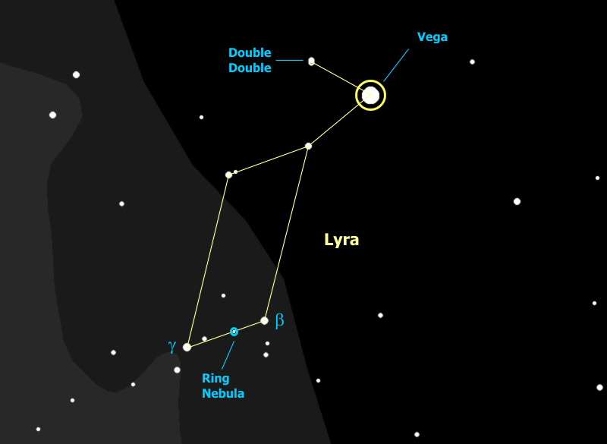
- The star next to Vega to the northeast (or up and to the left), ε (epsilon) Lyrae, is actually a double star when you look at it in binoculars. However, if we can get a good telescope on that star you will see that each of the stars in the double is itself a double - a very cool sight to see. These four stars form a set that is a true double-double star, formed from the same nebula, which was spinning so fast it first spun apart into two protostars. They in turn each spun themselves apart into two stars.
- The parallelogram star to the southwest, the lower right-hand corner of the lyre, is β (beta) Lyrae, which is another variable star - it is usually about as bright as the southeast, or lower left-hand corner star γ (gamma) Lyrae. Every 6½ days the star dims to half its brightness. This star is an "eclipsing binary" - two stars orbiting each other every 13 days. So every half orbit one of the stars passes in front of the other and instead of seeing two stars we only see one - the star drops to half its brightness, which is about a magnitude. This is different from a Cepheid variable, where the star itself is changing. So take a look at β Lyrae - do you think it's eclipsing right now?
- Now if we can get a telescope aimed right about half way between γ and β Lyrae (a little closer to β) and look in the eyepiece, you'll notice something a little funny - it doesn't look like a star at all, it looks more like a - smoke ring maybe. This is the famous Ring Nebula - another planetary nebula - a shell of gas blown off by a dying star, and lit up by the radiation from the exposed core of the star, now a "white dwarf".
Ring Nebula in Telescope | Hubble Telescope Image of Ring Nebula
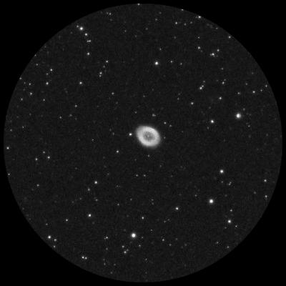 | 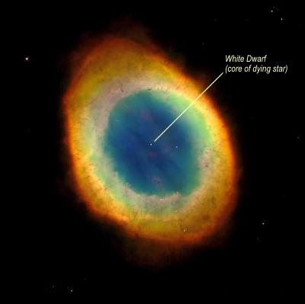

The Constellation Hercules
- Now as you go to the west, or to the right, of Lyra, you come upon another important asterism, "The Keystone". Just like it says, it is four stars in the shape of a keystone. {Trace out the Keystone.} And like the other asterisms it is a part of a larger constellation - the constellation Hercules. {Trace out Hercules.} The star that represents Hercules' head, a Herculis, is another red supergiant like Antares - by most estimates it's a little closer than Antares and since it's not as bright, we presume it is smaller. With a good telescope you can see that this reddish-orange star has a blue-green companion.
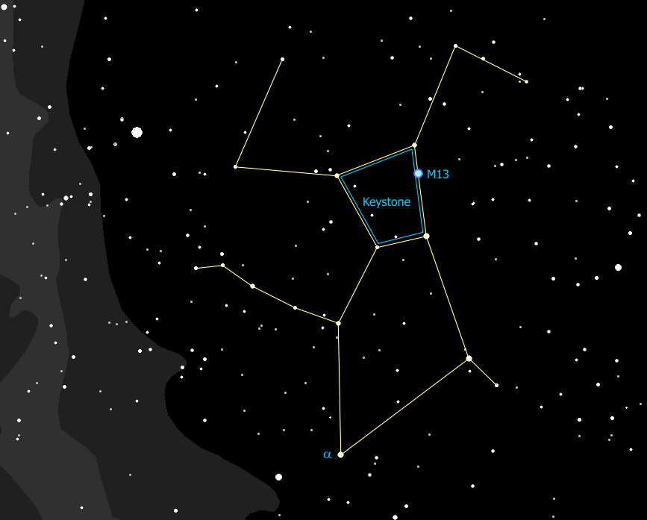
- One of the reasons for finding the Keystone is to help locate M13 - the brightest and best globular cluster in the Northern Hemisphere. Globular clusters are rare - only about 150 are known, and they are completely different from open clusters like the Butterfly Cluster that we saw in Scorpius.
The Butterfly is estimated to be about 100 million years old, M13 is estimated at about 10 BILLION years old, making it so old that it formed before the disk of the Milky Way galaxy formed! While the Butterfly cluster has maybe 100 stars in it total, M13 has no less than 1 million stars. The Butterfly cluster is about 1200 light-years away and about 20 light-years across, M13 is 20,000 light-years away and 160 light-years across.
These numbers are typical, so globular clusters are much, much bigger than open clusters, and they are much, much older - some are nearly as old as the universe!
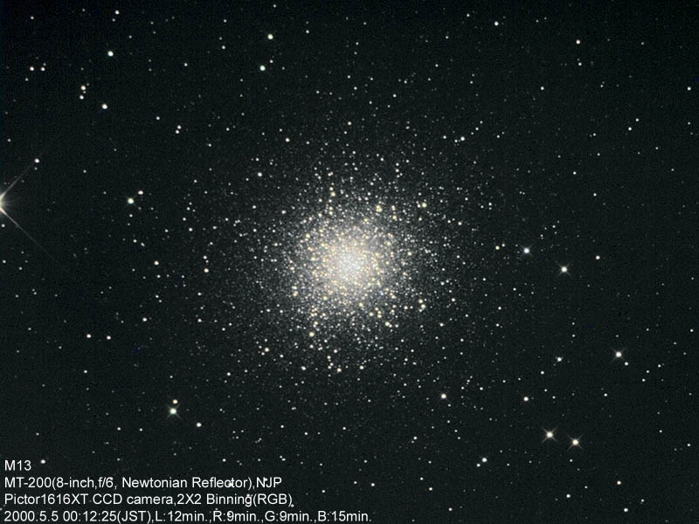

The Constellation Draco
- Hercules is pictured (upside down) in a kneeling position, on one knee, with his foot on the head of Draco the Dragon. {Trace out Draco.} Draco starts off with two bright yellow eyes (actually one's yellow, one's orange), and then winds around the little dipper with its tail between the two dippers. The lop-sided square that forms his head is known as "The Lozenge", and makes a very distinctive shape that helps you to recognize Draco. Who's got the binoculars? Use them to find Draco's eyes, then go down to find the next star in the Lozenge closest to the eyes -- ν (nu) Draconis. Notice anything? That's right, it's a double star, and a very neat one in binoculars, tight together and exactly equal in brightness.
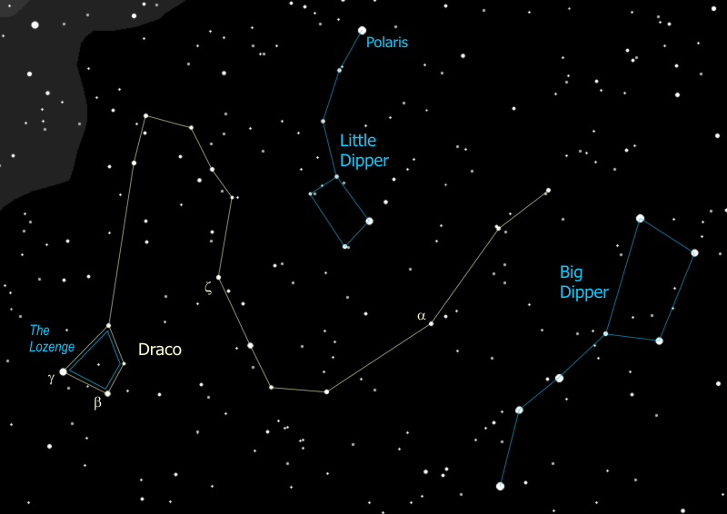
- The third star from the end of Draco's tail has its own name - Thuban - even though it's not very bright. What makes Thuban special is that it once was the North Star - about 5,000 years ago. Our North Pole is actually moving through the sky because the earth wobbles on its axis, just like a top does, particularly just before it falls over (no - the earth is not about to fall over). With the axis wobbling like that, the North Pole is tracing a circle in the sky - it just happens to be passing by Polaris right now.
It is about a degree away from our North Star now and will get about a half degree closer, then will start moving away as it continues on its circle through the sky. That circle will take it almost exactly right down the center of Cepheus, past Deneb in Cygnus, past Vega in Lyra, through Hercules leg and right by his knee, then down past Thuban and back to Polaris.
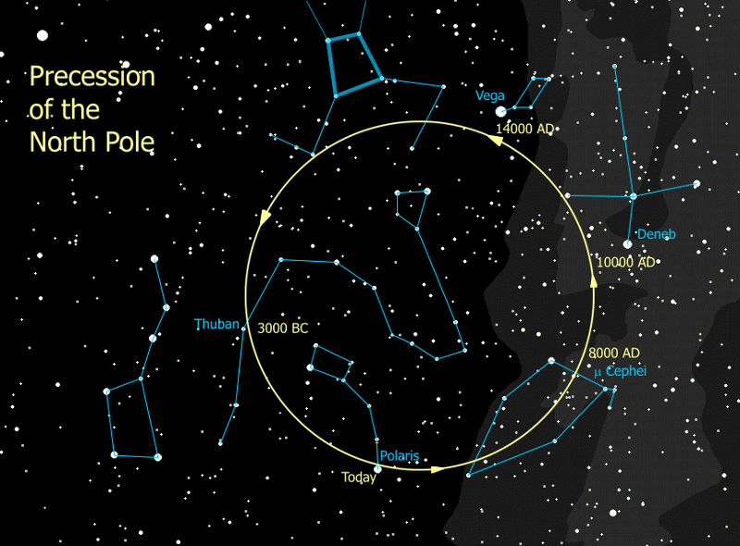
And speaking of coming full circle, we've come full circle. We started with the polar constellations and here we are, back at the polar constellations. Our summer sky tour is completed. For you die-hard stalwarts with a particularly high resistance to the night chill, we will continue on to learn a few additional constellations, and find a few additional interesting objects.
The hangers-on and those of us who still feel like playing with our telescopes will track down the following, and possibly other, items of interest. Also some of these get picked up during the tour, depending on where the questions, requests, and conversation end up going.
  - Serpens - Eagle Nebula M16 and Swan Nebula M17
  - Capricornus -- sometimes to try to find the planets Neptune/Uranus
  - Pegasus and M15
  - Andromeda and the Andromeda Galaxy M31
  - Globular Clusters M22 and M28 in Sagittarius

Tell Time by the Big Dipper

Using the Big Dipper to tell time (by the line from the pointer stars to Polaris) is easy.
- It's a backwards (counter-clockwise) running 24-hour clock, because the earth turns west to east a full turn every 24 hours, and
- It runs fast. Due to the earth's yearly orbit around the sun, it gains 24 hours each year.
So to use the clock you only need to do two things.
- Remember the 24-hour clock face, shown above, and
- Adjust the 24-hour (midnight) mark on the clock to the current date. 24 hours in 12 months is two hours every month, so shift the midnight mark up by two hours (counter-clockwise) on the clock each month, or a half-hour each week. Some key dates to remember are shown on the drawing.

